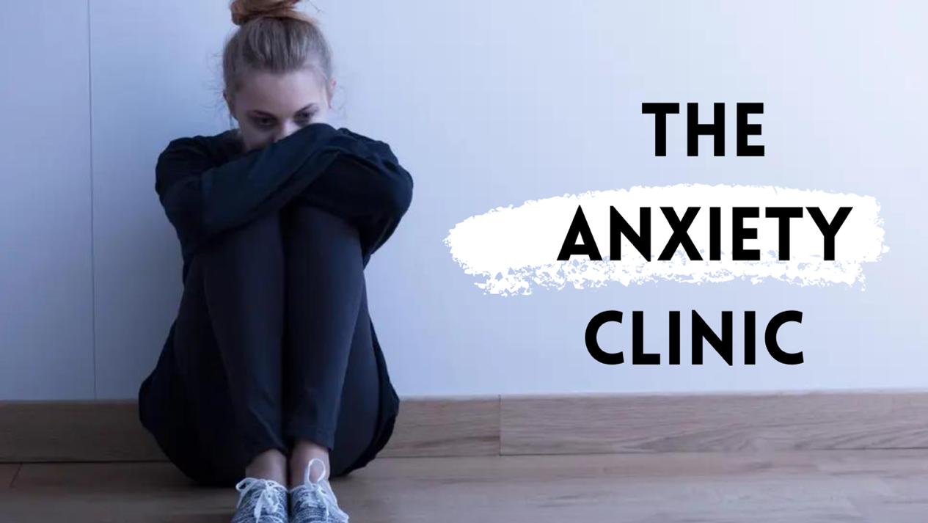
Understanding & Intervening with Anxious Children & Teenagers:
a seminar for parents, educators & mental health professionals.
We are experiencing epidemic levels of children and teenagers overwhelmed with anxiety. As young people struggle with school phobia, panic attacks, OCD, insomnia, self-harm and suicidal feelings - correspondingly, the adult world struggles to know what to do by way of support.
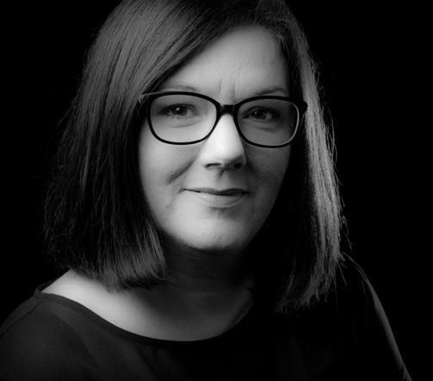
Join Bronagh Starrs, internationally renowned psychotherapist, trauma specialist, academic and author for The Anxiety Clinic - a seminar for parents and caregivers, educators, mental health practitioners and related professionals such as social workers and guidance counsellors to explore this issue in depth.
Participants will develop an understanding of the dynamics of anxious presentation in young people will be offered a trove of helpful strategies.
Date: Monday 05 September 2022
Online Event
Time: 10.00am – 3.00pm
Fee: £120
CPD: 5 Points
Registration Link: https://us02web.zoom.us/webinar/register/WN_dOnjot6GRdWajDgXoheL6A

